Python

Assignment – II

By

Mouli S

Batch - 02

[moulisankar2002@outlook.com](mailto:moulisankar2002@outlook.com)

**Question – 01**

Using Python, print triangle

* 1. Isosceles triangle
  2. Reverse right angle triangle

**Code:**

# printing triangle  
# a. isosceles  
# b. Reverse right angle triangle  
# ***************************************************************************************************  
import sys  
  
  
# Creating the functions  
  
# a. isosceles  
  
def generate_isosceles_tri():  
 for i in range(1**,** height + 1):  
 spaces = height - i  
 stars = 2 * i - 1  
 print(" " * spaces + "*" * stars)  
  
  
# b. reverse isosceles  
  
def generate_reverse_isosceles_tri():  
 for i in range(height**,** 0**,** -1):  
 for j in range(0**,** i):  
 print("*"**,** end=' ')  
 print()  
  
  
# Getting the triangle  
  
print('Which type of triangle you want? \n 1. Isosceles \n 2. Reverse Right angle Triangle')  
  
user_choice = input("Please enter your choice (1 or 2): ")  
  
# user choice validation  
  
try:  
 user_choice = int(user_choice)  
 if user_choice == 1 or user_choice == 2:  
 print('Your choice is'**,** user_choice)  
 else:  
 print('Oops!!! Provide the number between 1 and 2')  
 sys.exit()  
except ValueError:  
 print('Oops!!! Provide a number')  
 sys.exit()  
# finally:  
# print('Check the instruction correctly')  
  
# Creating the triangle  
try:  
 height = int(input("Enter the height of the triangle: "))  
except ValueError:  
 print('Oops!!! Enter the number only [Example: 1,2,3,.....]')  
 sys.exit()  
  
if user_choice == 1:  
 generate_isosceles_tri()  
else:  
 generate_reverse_isosceles_tri()

**Output:**

**1.**

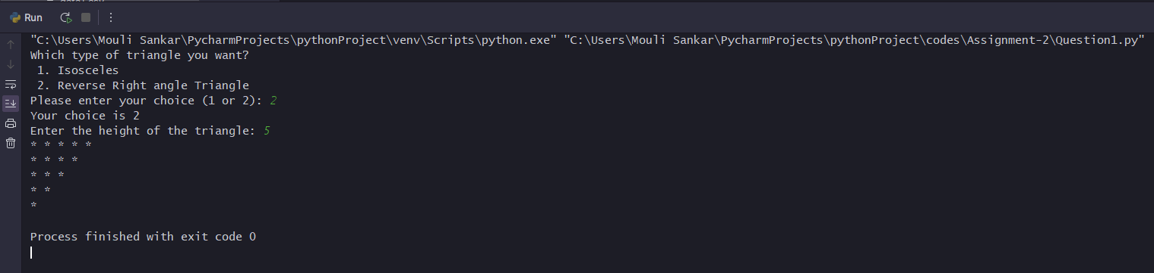

**2.**

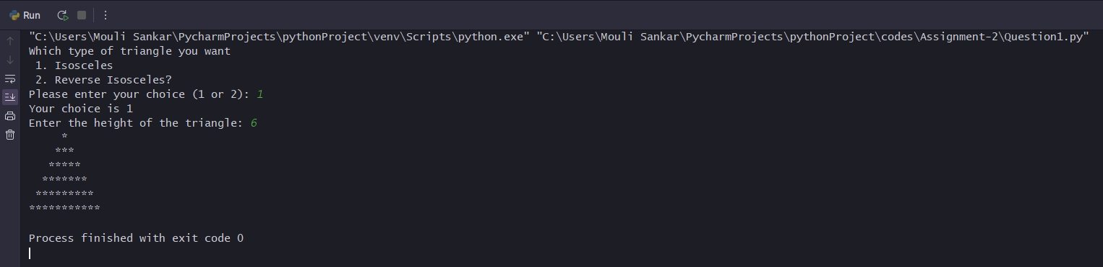

**Question - 02**

Read following API and load data into SQL Server DB:

* 1. <https://tools.learningcontainer.com/sample-json.json>
  2. https://tools.learningcontainer.com/sample-json-file.json

**Code:**

import json  
import pyodbc  
  
# Connect to the database  
conn = pyodbc.connect('Driver={SQL Server};'  
 'Server=Mouli-Sankar;'  
 'Database=Hexaware;'  
 'Trusted_Connection=yes;'  
 )  
cursor = conn.cursor()  
# Read the JSON data from the file  
with open('data1.json') as f:  
 data1 = json.load(f)  
  
with open('data2.json') as g:  
 data2 = json.load(g)  
  
# Insert data1 into json_1_tb  
query1 = "INSERT INTO json_1_tb (firstName, lastName, gender, age, streetAddress, city, state, postalCode, phoneNumberType, phoneNumber) VALUES (?, ?, ?, ?, ?, ?, ?, ?, ?, ?)"  
cursor.execute(query1**,** (  
 data1['firstName']**,** data1['lastName']**,** data1['gender']**,** data1['age']**,** data1['address']['streetAddress']**,** data1['address']['city']**,** data1['address']['state']**,** data1['address']['postalCode']**,** data1['phoneNumbers'][0]['type']**,** data1['phoneNumbers'][0]['number']))  
conn.commit()  
print('URL1 uploaded successfully!!')  
  
# Insert data2 into json_2_tb  
query2 = "INSERT INTO json_2_tb (Name, Mobile, Boolean, Pets, PermanentAddress, CurrentAddress) VALUES (?, ?, ?, ?, ?, ?)"  
cursor.execute(query2**,** (  
 data2['Name']**,** data2['Mobile']**,** data2['Boolean']**,** json.dumps(data2['Pets'])**,** # Convert the list to JSON string  
 data2['Address']['Permanent address']**,** data2['Address']['current Address']  
))  
conn.commit()  
print('URL2 uploaded successfully!!')  
  
# Close the connection  
conn.close()  
print('Job Successfully!!!!! Completed')

**Output:**

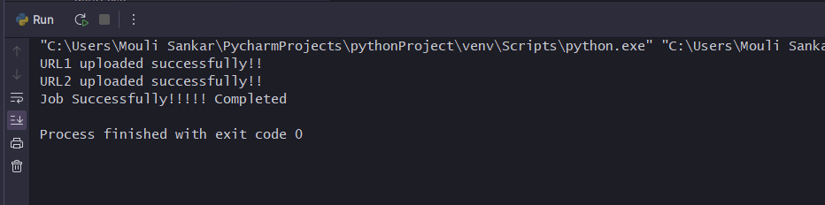

**Database:**

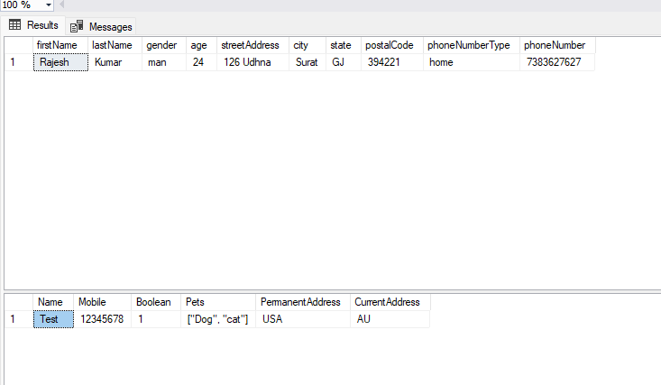

**Question – 03**

Generate Random Number between 0 to 10

* 1. Ask user to enter any guess number between 0 to 10.
  2. Accept User Input between 0 to 10
  3. Validate User Input if it is valid
  4. Print – what user has guessed is too low, too far, or exact (bang-on)

**Code:**

import random  
  
# Generate random number between 0 and 10  
number = random.randint(0**,** 10)  
  
# Ask user to enter a guess between 0 and 10  
guess = input("Guess a number between 0 and 10: ")  
  
# Validate user input  
if not guess.isdigit():  
 print("Invalid input. Please enter a number between 0 and 10.")  
 exit()  
  
guess = int(guess)  
if guess < 0 or guess > 10:  
 print("Invalid input. Please enter a number between 0 and 10.")  
 exit()  
  
# Compare the user's guess with the random number  
if guess == number:  
 print("You guessed it! The number was"**,** number)  
elif guess < number:  
 print("Your guess is too low.")  
else:  
 print("Your guess is too high.")

**Output:**

